Chapter 05
Risk and Return: Past and Prologue

- The 1% VaR will be less than -30%. As percentile or probability of a return declines so does the magnitude of that return. Thus, a 1 percentile probability will produce a smaller VaR than a 5 percentile probability.

- The geometric return represents a compounding growth number and will artificially inflate the annual performance of the portfolio.

- No. Since all items are presented in nominal figures, the input should also use nominal data.

- Decrease. Typically, standard deviation exceeds return. Thus, a reduction of 4% in each will artificially decrease the return per unit of risk. To return to the proper risk return relationship the portfolio will need to decrease the amount of risk free investments.

- E(r) = [0.3 × 44%] + [0.4 × 14%] + [0.3 × (–16%)] = 14%
σ² = [0.3 × (44 – 14)²] + [0.4 × (14 – 14)²] + [0.3 × (–16 – 14)²] = 540
σ = 23.24%
The mean is unchanged, but the standard deviation has increased.

  - The holding period returns for the three scenarios are:
Boom: (50 – 40 + 2)/40 = 0.30 = 30.00%
Normal: (43 – 40 + 1)/40 = 0.10 = 10.00%
Recession: (34 – 40 + 0.50)/40 = –0.1375 = –13.75%
E(HPR) = [(1/3) × 30%] + [(1/3) × 10%] + [(1/3) × (–13.75%)] = 8.75%
σ²(HPR) = [(1/3) × (30 – 8.75)2] + [(1/3) × (10 – 8.75)2] + [(1/3) × (–13.75 – 8.75)2]
= 319.79
σ = 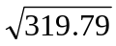= 17.88%

  - E(r) = (0.5 × 8.75%) + (0.5 × 4%) = 6.375%
σ = 0.5 × 17.88% = 8.94%

  - Time-weighted average returns are based on year-by-year rates of return.

Year | Return = [(capital gains + dividend)/price]
2007-2008 | (110 – 100 + 4)/100 = 14.00%
2008-2009 | (90 – 110 + 4)/110 = –14.55%
2009-2010 | (95 – 90 + 4)/90 = 10.00%
Arithmetic mean: 3.15%
Geometric mean: 2.33%

Time | Cash flow | Explanation
0 | -300 | Purchase of three shares at $100 per share
1 | -208 | Purchase of two shares at $110,  plus dividend income on three shares held
2 | 110 | Dividends on five shares,  plus sale of one share at $90
3 | 396 | Dividends on four shares,  plus sale of four shares at $95 per share

396

|

|

|

|

110

|

|

|

|

|

Date:

1/1/
0
7

1/1/
0
8

1/1/
0
9

1/1/
1
0

|

|

|

|

|

|

|

|

|

208

300

Dollar-weighted return = Internal rate of return = –0.1661%

  - E(r_{P}) – r_{f} = ½Aσ_{P}² = ½ × 4 × (0.20)² = 0.08 = 8.0%
  - 0.09 = ½Aσ_{P}² = ½ × A × (0.20)² ⇒ A = 0.09/( ½ × 0.04) = 4.5
  - Increased risk tolerance means decreased risk aversion (A), which results in a decline in risk premiums.

- For the period 1926 – 2008, the mean annual risk premium for large stocks over T-bills is 9.34%
E(r) = Risk-free rate + Risk premium = 5% + 7.68% =12.68%

- In the table below, we use data from Table 5.2. Excess returns are real returns since the risk free rate incorporates inflation.

Large Stocks: 7.68%
Small Stocks: 13.51%
Long-Term T-Bonds: 1.85%
T-Bills: 0.66 % (table 5.4)

  - The expected cash flow is: (0.5 × $50,000) + (0.5 × $150,000) = $100,000
With a risk premium of 10%, the required rate of return is 15%. Therefore, if the value of the portfolio is X, then, in order to earn a 15% expected return:
X(1.15) = $100,000 ⇒ X = $86,957

  - If the portfolio is purchased at $86,957, and the expected payoff is $100,000, then the expected rate of return, E(r), is:
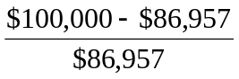= 0.15 = 15.0%
The portfolio price is set to equate the expected return with the required rate of return.

  - If the risk premium over T-bills is now 15%, then the required return is:
5% + 15% = 20%
The value of the portfolio (X) must satisfy:
X(1.20) = $100, 000 ⇒ X = $83,333

  - For a given expected cash flow, portfolios that command greater risk premia must sell at lower prices. The extra discount from expected value is a penalty for risk.

  - E(r_{P}) = (0.3 × 7%) + (0.7 × 17%) = 14% per year
σ_{P} = 0.7 × 27% = 18.9% per year

Security |  | Investment Proportions
T-Bills |  | 30.0%
Stock A | 0.7 × 27% = | 18.9%
Stock B | 0.7 × 33% = | 23.1%
Stock C | 0.7 × 40% = | 28.0%
  - Your Reward-to-variability ratio = S = 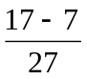= 0.3704
Client's Reward-to-variability ratio = 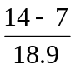= 0.3704

  - 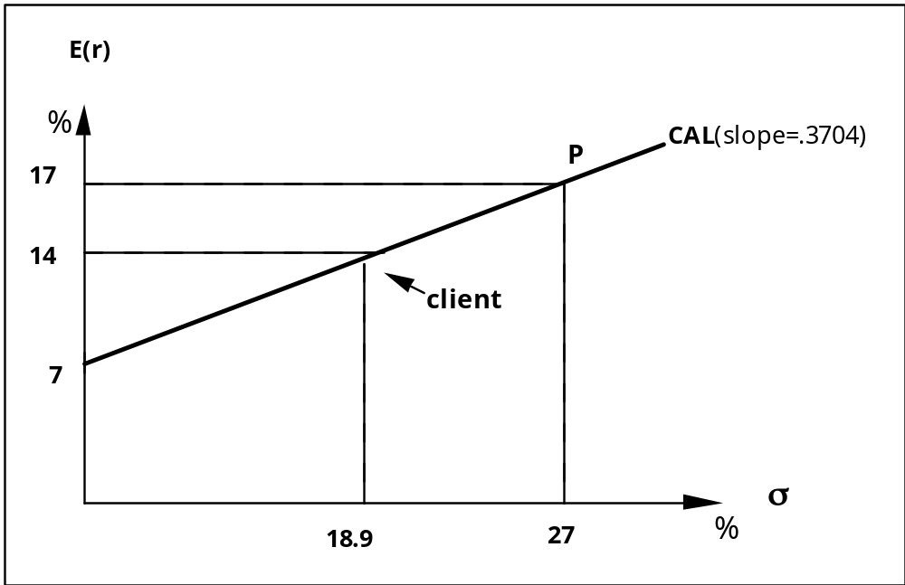

  - Mean of portfolio = (1 – y)rf + y rP = rf + (rP – rf )y = 7 + 10y
If the expected rate of return for the portfolio is 15%, then, solving for y:
15 = 7 + 10y ⇒ y = 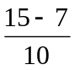= 0.8
Therefore, in order to achieve an expected rate of return of 15%, the client must invest 80% of total funds in the risky portfolio and 20% in T-bills.

Security |  | Investment Proportions
T-Bills |  | 20.0%
Stock A | 0.8 × 27% = | 21.6%
Stock B | 0.8 × 33% = | 26.4%
Stock C | 0.8 × 40% = | 32.0%
  - σ_{P} = 0.8 × 27% = 21.6% per year

  - Portfolio standard deviation = σ_{P} = y × 27%
If the client wants a standard deviation of 20%, then:
y = (20%/27%) = 0.7407 = 74.07% in the risky portfolio.

  - Expected rate of return = 7 + 10y = 7 + (0.7407 × 10) = 14.407%

  - Slope of the CML =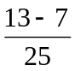= 0.24

See the diagram on the next page.

  - My fund allows an investor to achieve a higher expected rate of return for any given standard deviation than would a passive strategy, i.e., a higher expected return for any given level of risk.

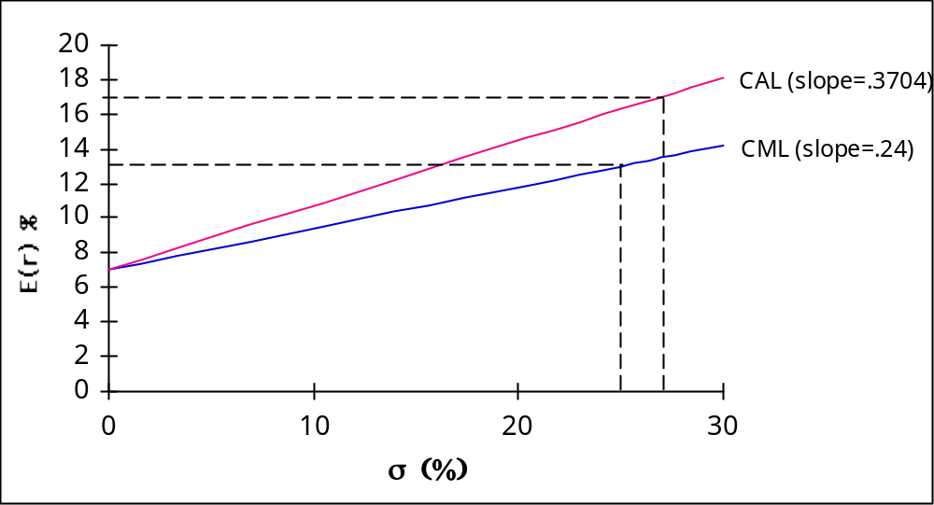

  - With 70% of his money in my fund's portfolio, the client has an expected rate of return of 14% per year and a standard deviation of 18.9% per year. If he shifts that money to the passive portfolio (which has an expected rate of return of 13% and standard deviation of 25%), his overall expected return and standard deviation would become:
E(r_{C}) = r_{f} + 0.7(r_{M} − r_{f})
In this case, r_{f} = 7% and r_{M} = 13%. Therefore:
E(r_{C}) = 7 + (0.7 × 6) = 11.2%
The standard deviation of the complete portfolio using the passive portfolio would be:
σ_{C} = 0.7 × σ_{M} = 0.7 × 25% = 17.5%
Therefore, the shift entails a decline in the mean from 14% to 11.2% and a decline in the standard deviation from 18.9% to 17.5%. Since both mean return and standard deviation fall, it is not yet clear whether the move is beneficial. The disadvantage of the shift is apparent from the fact that, if my client is willing to accept an expected return on his total portfolio of 11.2%, he can achieve that return with a lower standard deviation using my fund portfolio rather than the passive portfolio. To achieve a target mean of 11.2%, we first write the mean of the complete portfolio as a function of the proportions invested in my fund portfolio, y:
E(r_{C}) = 7 + y(17 − 7) = 7 + 10y
Because our target is: E(r_{C}) = 11.2%, the proportion that must be invested in my fund is determined as follows:
11.2 = 7 + 10y ⇒ y = 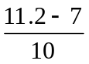= 0.42
The standard deviation of the portfolio would be:
σ_{C} = y × 27% = 0.42 × 27% = 11.34%
Thus, by using my portfolio, the same 11.2% expected rate of return can be achieved with a standard deviation of only 11.34% as opposed to the standard deviation of 17.5% using the passive portfolio.

  - The fee would reduce the reward-to-variability ratio, i.e., the slope of the CAL. Clients will be indifferent between my fund and the passive portfolio if the slope of the after-fee CAL and the CML are equal. Let f denote the fee:
Slope of CAL with fee = 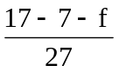= 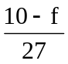
Slope of CML (which requires no fee) = = 0.24
Setting these slopes equal and solving for f:
= 0.24
10 − f = 27 × 0.24 = 6.48
f = 10 − 6.48 = 3.52% per year

- Assuming no change in tastes, that is, an unchanged risk aversion, investors perceiving higher risk will demand a higher risk premium to hold the same portfolio they held before. If we assume that the risk-free rate is unaffected, the increase in the risk premium would require a higher expected rate of return in the equity market.

- Expected return for your fund = T-bill rate + risk premium = 6% + 10% = 16%
Expected return of client’s overall portfolio = (0.6 × 16%) + (0.4 × 6%) = 12%
Standard deviation of client’s overall portfolio = 0.6 × 14% = 8.4%

- Reward to variability ratio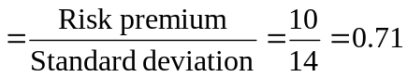

- Excess Return (%)
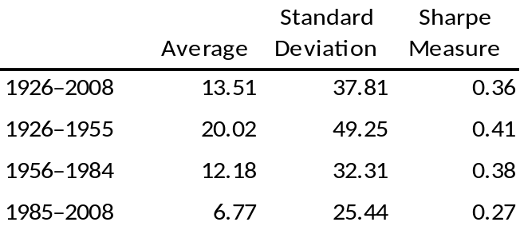

  - In three of the four time frames presented, small stocks provide worse ratios than large stocks.

  - Small stocks show a declining trend in risk, but the decline is not stable.

- Geometric return data is used from table 5.2 and geometric inflation data from table 5.4. Standard deviations are from the excess return data in table 5.2.
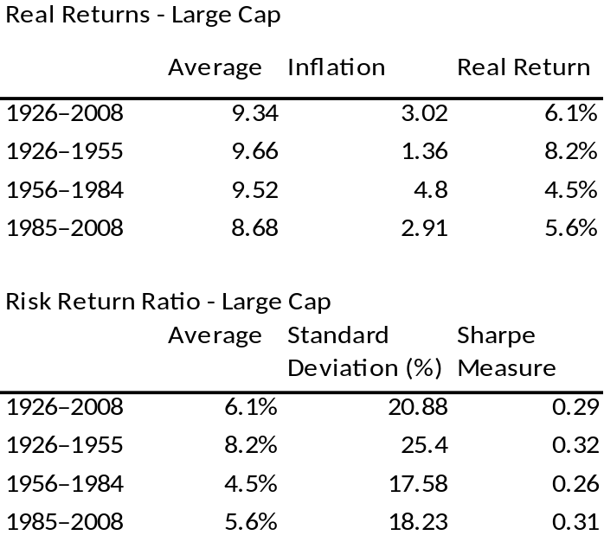

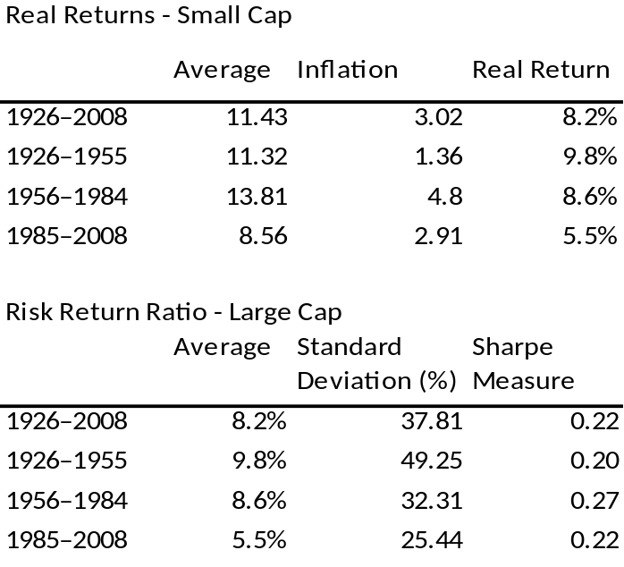

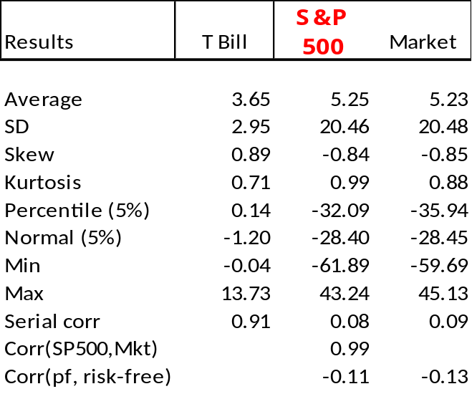

Comparison
The combined markets index represents the Fama-French market factor (Mkt). It is better diversified than the S&P 500 index since it contains approximately ten times as many stocks. The total market capitalization of the additional stocks, however, is relatively small compared to the S&P 500. As a result, the performance of the value weighted portfolios is expected to be quite similar, and the correlation of the excess returns very high. Even though the sample contains 82 observations, the standard deviation of the annual returns is relatively high, but the difference between the two indices is very small. When comparing the continuously compounded excess returns we see that the difference between the two portfolios is indeed quite small, and the correlation coefficient between their returns is 0.99. Both deviate from the normal distribution as seen from the negative skew and positive kurtosis. Accordingly, the VaR (5% percentile) of the two is smaller than what is expected from a normal distribution with the same mean and standard deviation. This is also indicated by the lower minimum excess return for the period. The serial correlation is also small and indistinguishable across the portfolios.

As a result of all this, we expect the risk premium of the two portfolios to be similar, as we find from the sample. It is worth noting that the excess return of both portfolios has a small negative correlation with the risk-free rate. Since we expect the risk-free rate to be highly correlated with the rate of inflation, this suggests that equities are not a perfect hedge against inflation. More rigorous analysis of this point is important, but beyond the scope of this question.

CFA 1
Answer: V(12/31/2007) = V(1/1/1991) × (1 + g)⁷ = $100,000 × (1.05)⁷ = $140,710.04

CF 2
Answer: i and ii. The standard deviation is non-negative.

CFA 3
Answer: c. Determines most of the portfolio’s return and volatility over time.

CFA 4
Investment 3. For each portfolio: Utility = E(r) – (0.5 × 4 × σ² )

Investment | E(r) | σ | U
1 | 0.12 | 0.30 | -0.0600
2 | 0.15 | 0.50 | -0.3500
3 | 0.21 | 0.16 | 0.1588
4 | 0.24 | 0.21 | 0.1518
We choose the portfolio with the highest utility value.

CFA 5
Answer: Investment 4. When an investor is risk neutral, A = 0 so that the portfolio with the highest utility is the portfolio with the highest expected return.

CFA 6
Answer: b

CFA 7
E(r_{X}) = [0.2 × (–20%)] + [0.5 × 18%] + [0.3 × 50%)] = 20%
E(r_{Y}) = [0.2 × (–15%)] + [0.5 × 20%] + [0.3 × 10%)] = 10%

CFA 8
σ_{X}² = [0.2 × (–20 – 20)²] + [0.5 × (18 – 20)²] + [0.3 × (50 – 20)²] = 592
σ_{X} = 24.33%
σ_{Y} = [0.2 × (–15 – 10)²] + [0.5 × (20 – 10)²] + [0.3 × (10 – 10)²] = 175
σ_{Y} = 13.23%

CFA 9
E(r) = (0.9 × 20%) + (0.1 × 10%) = 19%

CFA 10
The probability is 0.50 that the state of the economy is neutral. Given a neutral economy, the probability that the performance of the stock will be poor is 0.30, and the probability of both a neutral economy and poor stock performance is:
.30 × 0.50 = 0.15

CFA 11
E(r) = [0.1 × 15%] + [0.6 × 13%] + [0.3 × 7%)] = 11.4%

